7COM1079-0901-2024 - Team Research and Development Project

Final report title: Exploring the Correlation Between Population Density and Median House Prices: A Case Study of London Boroughs

Group ID: A238

Dataset number: DS161

Prepared by:

Esika Arifin Rumky – 23027070

Hodan Abdi - 24053927

Azubuike Precious Iheayichukwu - 23076064

Jason Banks - 20050575

MD Humayun Kibria Shakib - 23086078

University of Hertfordshire

Hatfield, 2024

1. Introduction 3

1.1 Problem Statement and Research Motivation 3

1.2 The Dataset 3

1.3 Research Question 3

1.4 Hypotheses 3

2.Background Research 4

2.1 Research Papers 4

2.2 Why this Research Question is of interest 4

3. Visualization 5

3.1 Appropriate Plots for the RQ Output: Histogram and Scatter Plot Analysis 5

3.2 Additional Information Relating to Understanding the Data 6

3.3 Useful Information for Data Understanding 6

4. Analysis 7

4.1 Statistical Test and Output: 7

4.2 Null Hypothesis is Rejected Based on the P-Value 7

5. Evaluation – Group’s Experience at 7COM1079 8

5.1 What Went Well 8

5.2 Points for Improvement 8

5.3 Group’s Time Management 8

5.4 Project’s Overall Judgement 8

5.5 Changes to Group 8

5.6 Comment on the GitHub Log Output 9

6. Conclusions 10

6.1 Results Explained 10

6.2 Interpretation of the Results 10

6.3 Reasons and/or Implications for Future Work, Limitations of Our Study 10

7. References 11

8. Appendices 12

Appendix A: R Code for Analysis and Visualization 12

Appendix B. GitHub Log Output 14

# 1. Introduction

## 1.1 Problem Statement and Research Motivation

In this report we will be looking at the relationship between house prices and population density in London boroughs. Affordable housing is a growing concern in urban areas, particularly in London's borough, where median house prices have skyrocketed in recent years. This poses challenges for policy-makers who strive to balance urban growth with affordable living conditions.

Understanding how factors such as population density, employment rates, and greenspace percentage influence housing costs is vital. Prior research, such as Smith et al. (2020), emphasizes the importance of examining these socioeconomic and environmental variables to gain deeper insights into housing market dynamics.

## 1.2 The Dataset

The "London Borough Profiles 2016" dataset (Dataset ID: DS161) is interesting because it provides comprehensive insights into London's boroughs' socioeconomic and demographic characteristics. It allows for analysing how population density, employment rates, and greenspace influence key outcomes such as house prices, providing a deeper understanding of urban living conditions and economic trends. Our team chose this dataset to explore whether crowded neighbourhoods correlate with higher house prices.

## 1.3 Research Question

The following is the research question in this study.

*Is there a correlation between the house price and population density in London boroughs?*

This question will be addressed by employing statistical analysis and visualization techniques using RStudio to explore the relationships between the independent variables (population density per hectare, 2016) and the dependent variable (median house prices, 2014).

## 1.4 Hypotheses

* **Null Hypothesis (H₀):** There is no correlation between the house price and population density in London boroughs.
* **Alternative Hypothesis (H₁):** There is a correlation between the house price and population density in London boroughs.

To test these hypotheses Spearman’s Rho, which is a non-parametric statistical method, will be utilized due to the non-normal distribution of the data. This approach ensures robust results, enabling an accurate assessment of the relationships between population density and housing costs.

# 2.Background Research

## 2.1 Research Papers

Research shows important insights about how population density and housing prices are connected. A study in Sacramento County (Sharpe, 2019), “*The Effects of Population Density on Home Prices,*” analysed over 10,000 home sales and census data using a hedonic price model. It found a curved relationship between population density and housing prices highlighting how density significantly influences property values.

Maxwell (n.d.), in *"Structural and Spatial Determinants of London House Prices,"* studied how different factors, like population density, affect housing prices in London. This study gives useful details about how the housing market works in London and fits well with the current research. Maxwell’s work highlights how space and structure influence housing prices across different boroughs.

Johnston et al. (2016), in *"House Price Increases and Higher Density Housing Occupation,"* examined how higher house prices and crowded areas have impacted different groups of people in London. The study sought to investigate social differences, especially with respect to non-white households. This research helps demonstrate the impact of population density on housing prices and social changes, thus enhancing the relevance of this research.

Together, these studies provide a strong foundation for this work, addressing a crucial gap that allows understanding how population density and housing prices are different among London’s boroughs.

## 2.2 Why this Research Question is of interest

The research question holds importance because it identifies a specific gap in understanding the relation of population density with housing prices within London's boroughs. Earlier studies tried to evaluate housing prices and density but mostly talked about broad trends and hardly compared differences between particular boroughs. The present research takes a closer look at variations in population density across high- and low-priced boroughs. This localized analysis provides practical insights to urban planning and housing policies. The study fills the gap in area-specific research as it pertains to London, helping policymakers address challenges relating to affordability and population density.

# 3. Visualization

## 3.1 Appropriate Plots for the RQ Output: Histogram and Scatter Plot Analysis

A histogram with an overlaid density curve (Figure 3.1.1) was chosen to visualize the distribution of median house prices in London boroughs (2014), showing a left-skewed trend. A scatterplot (Figure 3.1.2) was used to display the positive correlation between population density and house prices, with a fitted line highlighting the relationship.

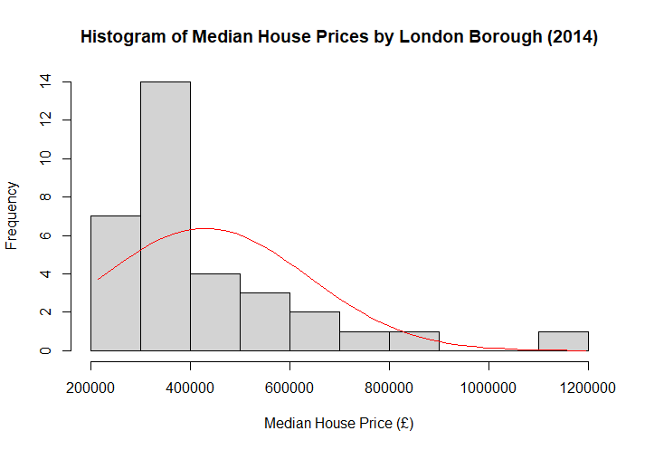

Fig: 3.1.1

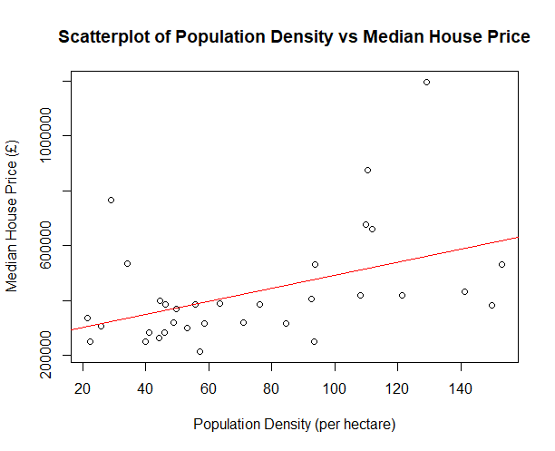

Fig: 3.1.2

## 3.2 Additional Information Relating to Understanding the Data

The histogram displays the frequency of house prices grouped into specific ranges, which aids in identifying patterns in the housing market. The overlaid density curve provides additional insights by highlighting the overall distribution trend of the data. Notably, the distribution is not normal and exhibits a left-skewed pattern, indicating a higher concentration of house prices in the lower range.

## 3.3 Useful Information for Data Understanding

1. The histogram [Figure 3.1.1] shows that most boroughs have lower house prices, with only a few boroughs in the higher price ranges, indicating a right-skewed distribution.
2. The scatterplot [Figure 3.1.2] shows the correlation between population density (per hectare) and median house prices in each borough. A fitted trend line illustrates the weak positive correlation between these two variables.

# 4. Analysis

## 4.1 Statistical Test and Output:

As the dependent variable is not normally distributed, a Spearman’s Rho test was conducted to assess the correlation between population density and median house prices in London boroughs. This non-parametric method ensures reliable results. The test yielded a Spearman’s Rho value of 0.4989 with a p-value of 0.0031, which is less than indicating a statistically significant moderate to strong positive correlation. This suggests the observed relationship is unlikely due to chance, affirming a meaningful connection between the variables.

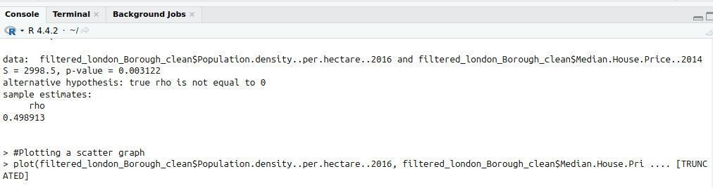

Fig: 4.1.1

## 4.2 Null Hypothesis is Rejected Based on the P-Value

The null hypothesis (H₀), which states that there is no correlation between house prices and population density in London boroughs, is **rejected**. The low p-value provides strong evidence for a significant positive correlation between these two variables.

This result implies that boroughs with higher population densities tend to have higher median house prices. It highlights the influence of urban population distribution on housing market trends, emphasizing the importance of managing population density in urban planning and housing policy.

# 5. Evaluation – Group’s Experience at 7COM1079

## 5.1 What Went Well

We worked collaboratively in our group using our different skill sets to produce a great project. As a team we effectively communicated objectives and held regular team meetings which led to the completion of tasks and delivering them on time. We prioritised providing support to team members when challenges arose. To collaborate effectively we used tools like GitHub and Trello to version control and organize our work. Issues were identified early through regular peer reviews, enhancing the overall quality of our work.

## 5.2 Points for Improvement

It has been a great project, but an area for improvement is evenly distributing work better as some members took on more work than others. Work would pile up on those who were more committed as some were reluctant to contribute. Additionally, occasionally communicational issues would arise causing late decisions. Further, features were more deeply embedded than we thought which led to last-minute changes. Future projects would benefit from more adequate time management, better communications, and earlier awareness of possible risks so we could avoid potential issues.

## 5.3 Group’s Time Management

Our group did well at time management. We used a collaboration tool called Trello to organise tasks and would set deadlines so that we could produce work consistently. During the holidays we did struggle to continue with constantly producing work but picked up on producing work as soon as it finished. Future efforts should focus on allocating buffer time for holidays and other unexpected delays.

## 5.4 Project’s Overall Judgement

The assignment was successful as we accomplished all our team objectives. Effective teamwork, communication and regular progress checks were the key to our success. This project highlights our strong team working skills. We enjoyed working together as a team to collaborate together and produce work that we are all proud of.

## 5.5 Changes to Group

Since Assignment 1, there were no changes to the group composition or roles, and no new GitHub IDs were added or amended. The team structure and responsibilities remained the same, allowing for continuity and consistency throughout the project. This stability ensured that all members were familiar with their tasks and workflow, contributing to effective collaboration and efficient execution. The absence of changes allowed us to maintain focus on project deliverables and achieve our objectives seamlessly.

## 5.6 Comment on the GitHub Log Output

From the GitHub log, significant commits stand out (refer to Appendix B):

1. **Commit Message:** "[Added Analysis Group Evaluation, Conclusion, Reference, R code]" – Introduced critical sections to the report.
2. **Commit Message:** "[Visualisation using a histogram and scatterplot]" – Enhanced the data presentation.
3. **Commit Message:** "[Filtering dataset, reducing columns, and removing missing data]" – Improved dataset quality, ensuring accuracy.

# 6. Conclusions

## 6.1 Results Explained

Graphically, the analysis shows a significant positive correlation between population density and median house prices in London boroughs with a Spearman's Rho value of **0.498913** and a statistically significant p-value of **0.0031**. It means that boroughs with high population densities have higher housing costs. The scatter plot and histogram complement by showing a further relationship and distribution patterns. Such findings conform to urban economic theories postulating increasing demand and property values with population density.

## 6.2 Interpretation of the Results

These findings reveal that housing costs in London are slightly influenced by a positive correlation with population density. This highlights urban pressures in densely populated boroughs, where housing demand raises property prices. The study's implications extend to urban planning, emphasizing managing population densities to alleviate housing costs and promote equitable policies. Policymakers must prioritize affordability in high-density areas, ensuring economic and social balance while addressing housing challenges in such settings.

## 6.3 Reasons and/or Implications for Future Work, Limitations of Our Study

A limitation of our study is the use of data from different years (2014 and 2016) for the two variables. Future work could involve exploring how the correlation between house prices and population density in London boroughs evolves over time and investigating potential reasons for any observed changes.

# 7. References

Sharpe, R. (2019). *The effects of population density on home prices*. CSUS Research Portal. [online] Available at: <https://scholars.csus.edu/esploro/outputs/graduate/The-effects-of-population-density-on/99257831021701671>

Johnston, R., Owen, D., Manley, D. and Harris, R. (2016). *House price increases and higher density housing occupation: the response of non-white households in London, 2001–2011*. International Journal of Housing Policy, 16(3), pp.357–375. doi:https://doi.org/10.1080/14616718.2015.1130607. Available at: <https://research-information.bris.ac.uk/en/publications/house-price-increases-and-higher-density-housing-occupation-the-r>

Maxwell, H. (n.d.). *Structural and Spatial Determinants of London House Prices*. www.academia.edu. [online] Available at: <https://www.academia.edu/24939620/Structural_and_Spatial_Determinants_of_London_House_Prices>

# 8. Appendices

## Appendix A: R Code for Analysis and Visualization

#installing packages

library(readr)

install.packages("tidyverse")

#importing dataset into r

dataset <- read.csv("/home/imran/Downloads/london-borough-profiles-2016-Data-set2.csv")

colnames(dataset)

#Filtering to create a new df with only the three columns we are interested in.

filtered_london_Borough <- dataset[c("Area.name", "Median.House.Price..2014", "Population.density..per.hectare..2016" )]

#Cleaning or data by creating a new df with no missing values

filtered_london_Borough_clean <- subset(filtered_london_Borough, !Area.name %in% c("","Inner London", "Outer London", "London", "England", "United Kingdom", "National comparator"))

#Further clean of data by removing commas from price e.g. 750,000 -> 750000

filtered_london_Borough_clean$Median.House.Price..2014 <-

gsub(",", "", filtered_london_Borough_clean$Median.House.Price..2014)

#Change character data type to numeric data type

filtered_london_Borough_clean$Median.House.Price..2014 <- as.numeric(filtered_london_Borough_clean$Median.House.Price..2014)

filtered_london_Borough_clean$Population.density..per.hectare..2016 <- as.numeric(filtered_london_Borough_clean$Population.density..per.hectare..2016)

head(dataset,2)

head(filtered_london_Borough_clean,2)

###########Visualization##########

#Histogram and Box plot for dependent variable median house price

h <-hist(filtered_london_Borough_clean$Median.House.Price..2014, breaks = 10, xlab = "Median House Price (£)", ylab = "Frequency", main =

"Histogram of Median House Prices by London Borough (2014)")

boxplot(filtered_london_Borough_clean$Median.House.Price..2014, ylab="Median House Price (£)", main="Box Plot of Median House Prices by London Borough (2014)", horizontal = TRUE)

x <- seq(min(filtered_london_Borough_clean$Median.House.Price..2014), max(filtered_london_Borough_clean$Median.House.Price..2014), length= 40)

y <- dnorm(x, mean=mean(filtered_london_Borough_clean$Median.House.Price..2014), sd=sd(filtered_london_Borough_clean$Median.House.Price..2014))

y <- y * diff(h$mid[1:2]) * length(filtered_london_Borough_clean$Median.House.Price..2014)

lines(x,y,col="red")

#Histogram and Box plot for independent variable population density

h <-hist(filtered_london_Borough_clean$Population.density..per.hectare..2016, breaks = 10, xlab = "Frequency", ylab = "Population Density (per hectare)", main =

"Histogram of Population Density (per hectare) in London BoroughS (2016)")

boxplot(filtered_london_Borough_clean$Population.density..per.hectare..2016)

#As our data is not normal we are going to use spearmans correlation

cor.test(filtered_london_Borough_clean$Population.density..per.hectare..2016,

filtered_london_Borough_clean$Median.House.Price..2014, method="spearman")

#Plotting a scatter graph

plot(filtered_london_Borough_clean$Population.density..per.hectare..2016, filtered_london_Borough_clean$Median.House.Price..2014, xlab="Population Density (per hectare)", ylab="Median House Price (£)", main="Scatterplot of Population Density vs Median House Price")

#Line on the scatter plot

abline(lm(filtered_london_Borough_clean$Median.House.Price..2014 ~ filtered_london_Borough_clean$Population.density..per.hectare..2016), col ="red")

## Appendix B. GitHub Log Output

Fig: GitHub Log Output

On GitHub, we maintained consistent progress tracking by logging updates regularly. The log highlights our team’s workflow and incremental steps in developing the project. Key and meaningful commit messages provide a transparent overview of contributions, with detailed records available for review on the GitHub repository. You can find our github repository link here: [click here](https://github.com/er23abe/A238_Team_Research/tree/main)

| **Commit ID** | **Author** | **Time** | **Commit Message** |
| --- | --- | --- | --- |
| 354e951 | Esika Rumky | 4 minutes ago | Merge branch 'main' of https://github.com/er23abe/A238_Team_Research |
| 8bddbef | Esika Rumky | 5 minutes ago | Updated git log file |
| 0610186 | Hodan Abdi | 21 minutes ago | Adding to Evaluation |
| 5d54361 | Hodan Abdi | 1 hours ago | Adding to Analysis |
| 78d555a | Hodan Abdi | 1 hour ago | Histogram and Scatter Plot Analysis |
| 8c7cfdd | Hodan Abdi | 1 hour ago | Changes to Introduction |
| ff2b974 | Banks | 1 hour ago | Fixed formatting and references - ref 1 doesn’t work |
| 7c3bb6b | Hodan Abdi | 1 hour ago | Changes to introduction |
| 3121306 | Banks | 1 hour ago | Fixed formatting and references - ref 1 doesn’t work |
| 43a83e7 | Banks | 1 hour ago | reviewed file |
| 29182e9 | Esika Rumky | 15 hour ago | Updated the reviewed section |
| 40c2c31 | Banks | 1 day ago | added changes I made to the other file onto this one along with my contributions to section 4 (and other comments) |
| 969769f | Esika Rumky | 2 days ago | Added GitHub Log Output |
| 0957527 | Esika Rumky | 2 days ago | Adding git log file |
| 2ffb0ad | Esika Rumky | 2 days ago | Added Analysis,Group Evaluation,Conclusion,Reference ,R code |
| c4072fd | Esika Rumky | 2 days ago | Delete 7COM1079_report_introduction.docx |
| dc0dfee | Esika Rumky | 2 days ago | Add files via upload |
| 9dd3340 | Banks | 3 days ago | fixed paragraph spacing added comments with ideas for changes. |
| ca46128 | Esika Rumky | 4 days ago | Add files via upload |
| c7cc5ee | Esika Rumky | 1 week ago | I have added background research in the report. |
| 2b195a7 | precious-herts | 2 weeks ago | Added the report document 7COM1079_report_introduction.docx as well as chapter 1 which is introduction |
| b56f28b | Hodan Abdi | 6 weeks ago | Merge branch 'visualisation-and-presentation-work' |
| ee9e002 | Hodan Abdi | 6 weeks ago | Merge branch 'main' of https://github.com/er23abe/A238_Team_Research |
| 911585e | Hodan Abdi | 6 weeks ago | adding head(dataset 2) to R file |
| 2cabb4f | humayunshakib | 6 weeks ago | Update Readme |
| ec60827 | Hodan Abdi | 6 weeks ago | Visualisation using a histogram and scatterplot |
| 22b68ae | Hodan Abdi | 7 weeks ago | filtering dataset reducing col and removing missing data |
| 4226d59 | Hodan Abdi | 7 weeks ago | Revert "data in relation to your research question.ipynb" |
| 513f033 | Hodan Abdi | 7 weeks ago | Revert " Python Code for showing histogram diagram" |
| 5e49d94 | Hodan Abdi | 7 weeks ago | Revert " data visualization of relation to our research question" |
| 52587d8 | Hodan Abdi | 7 weeks ago | Revert " data visualization of showing histogram" |
| edbc388 | Hodan Abdi | 7 weeks ago | Revert " Updating git log File" |
| a03ccc8 | Esika Rumky | 7 weeks ago | Updating git log File |
| 413614b | Esika Rumky | 7 weeks ago | data visualization of showing histogram |
| df9734c | Esika Rumky | 7 weeks ago | data visualization of relation to our research question |
| 899a2aa | Esika Rumky | 7 weeks ago | Python Code for showing histogram diagram |
| ae948a4 | Esika Rumky | 7 weeks ago | data in relation to your research question.ipynb |
| 35ee4b3 | Banks | 7 weeks ago | added some code for the form assignment (creating subset of rows we need). |
| e092985 | precious-herts | 7 weeks ago | I made some modifications to our reseach questionnull hypothesis and alternate hypothesis. I also changed the name of the presenter to Azubuike Precious |
| cc2799c | Hodan Abdi | 7 weeks ago | Uploading dataset to RStudio |
| d4dadc9 | er23abe | 8 weeks ago | Add files via upload |